WEBTESTING SE1LENIUM

CC1

KALAIVARSHAA

727721EUIT064

Q1]

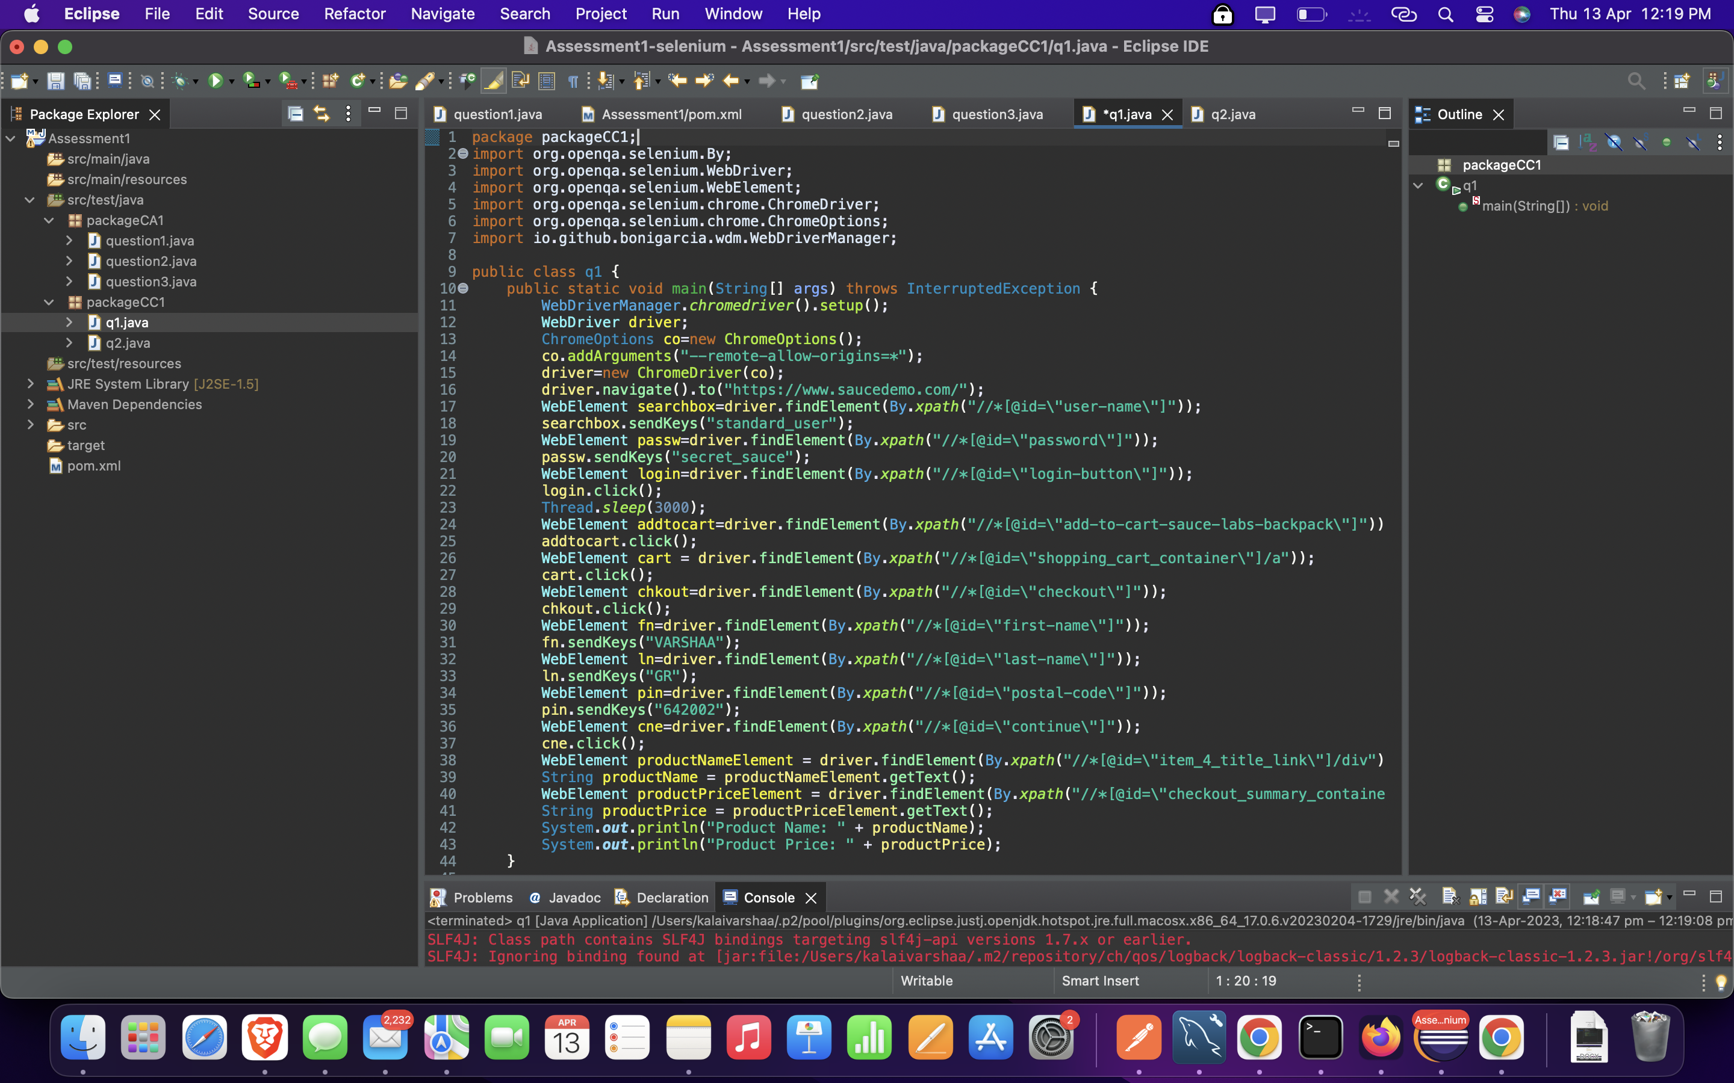

OUTPUT:

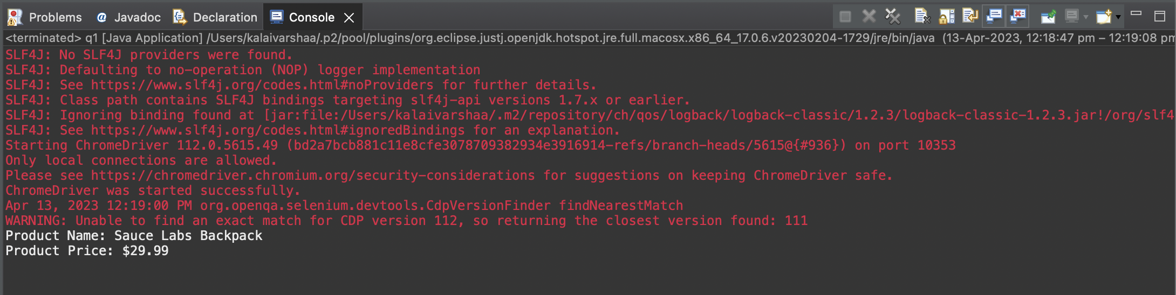

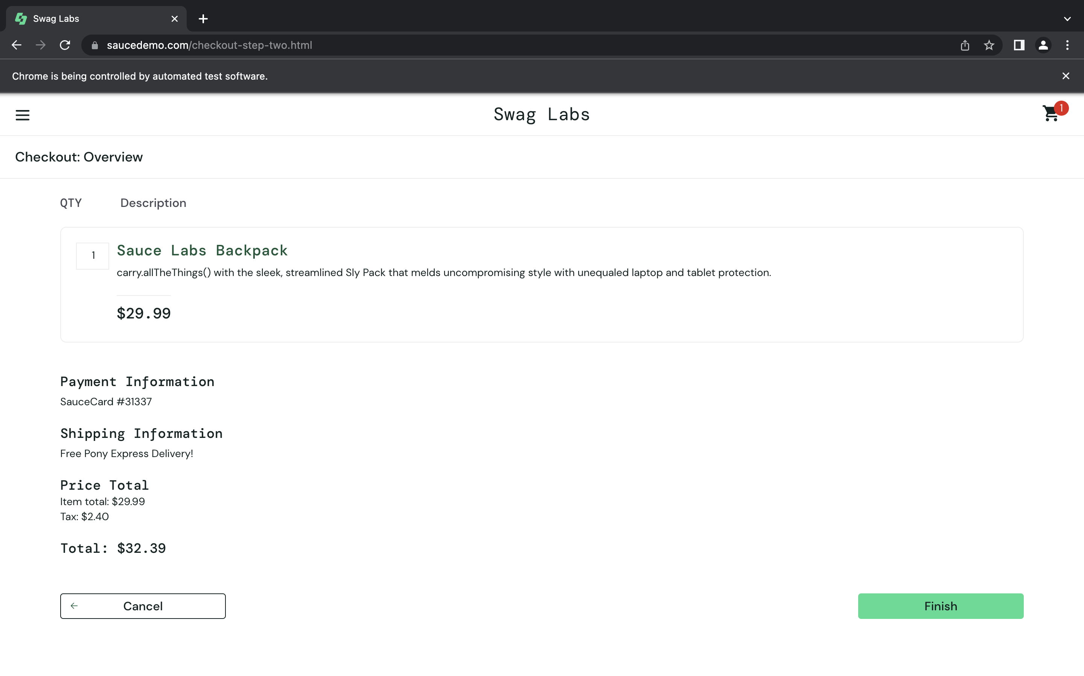

Q2]

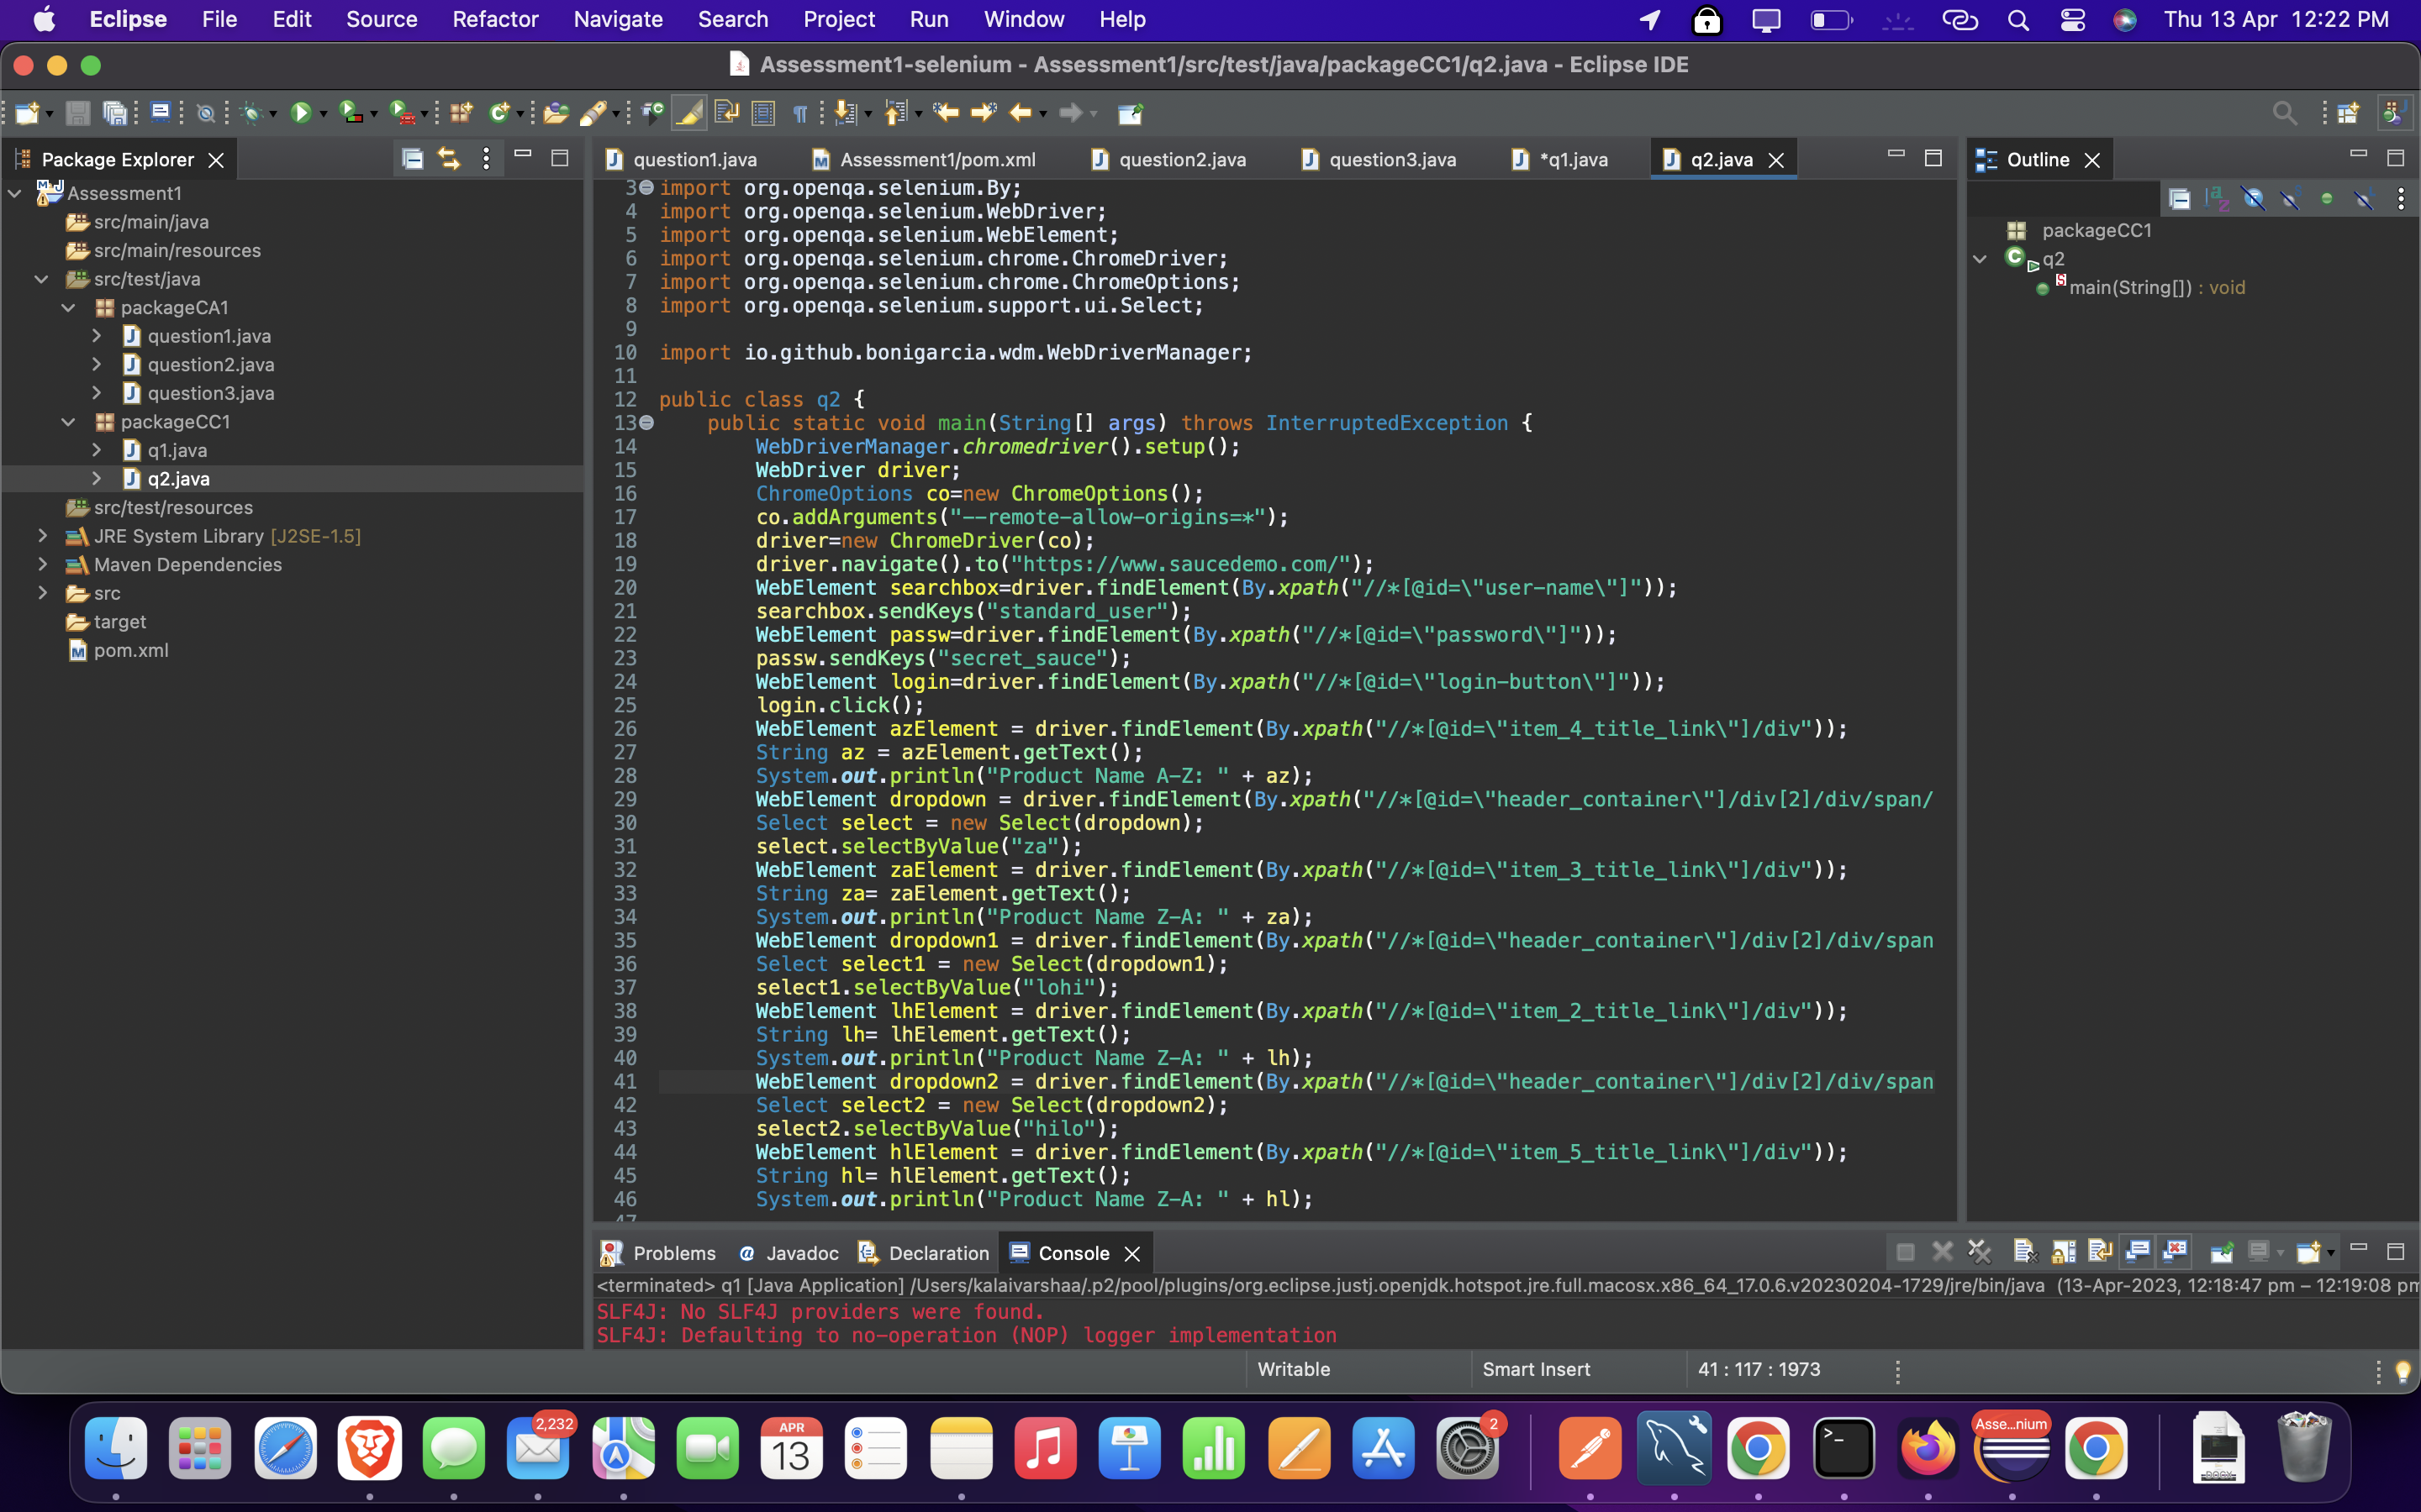

OUTPUT:

